You own a restaurant, and you want good reviews, but what really matters? Answering this question that permeates the minds of restaurant owners everywhere, is exactly the goal of this project. To accomplish this goal, we will use Topic Modeling(Latent Dirichlet Allocation) and sentiment analysis from Spark MLlib on 4.7M restaurant reviews from 12 metropolitan areas provided by Yelp.com, to better understand key themes and sentiments that appear in reviews for restaurants across various cuisines.Then through a regression analysis, we aim to derive insights about what dining experience topics carry the most weight when explaining restaurant star rating reviews

[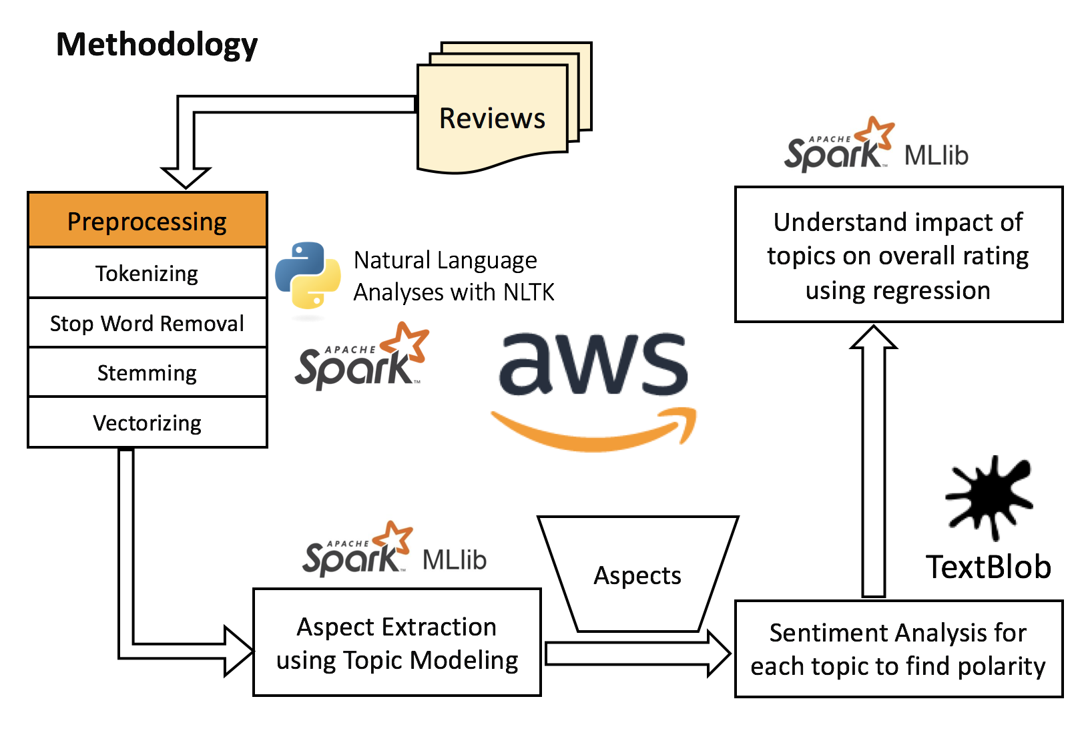](https://user-images.githubusercontent.com/29344615/33693044-1e1ef026-dab6-11e7-9c95-e0dbd84279b4.png)